Game Plan, Quian’Dor

Introduction
Quian’Dor, what to be said about it. The major goal behind this project was to make a world where anything would be possible, as long as the player could think of a good reason for it. We started it out completely wrong, I realize that as I look back on the first concepts, for we started without doing any research on the subjects that we are going to use in the game. The most important thing what I, personally, wanted to incorporate was intelligence. Most RPGs these days have awesome settings and stories, but the characters were never really interesting. This is where the books differ from video games, books have so much more time to explain everything about everyone, so you can get attached to virtually everyone. I wanted to capture this feel with Quian’Dor, and so far I have succeeded to already get a few people attached to what I thought of. The NPCharacters will have background, knowledge, and human attributes. There will be some people who have fear, who hesitate before swearing an oath, the characters you always read about in books, but never in video games. This, hard it may be, was in the end my ultimate goal for Quian’Dor, besides from making it a kickass game.
~Pim

When I first came to Quian'Dor, it was using pics1 tileset, a 1000+ level map and plans to use simple systems. However, over the past 6 – 8 months, that idea has blossomed in to plans for a game so innovative and revolutionary, it's unbelievable. If I were to compare Quian'Dor as it was in June 2007 to the Quian'Dor of today, I wouldn't believe they were the same world. It's fair to say that Quian'Dor has come a long way since then. Heavy development on the current world is underway.
The goal of the project is still the same: to create a world where anything is possible. However, the difference being that the current project is automated and scripted, more like a game. Unlike your Joe-Bloggs average game though, everything will have a background, a reason, etc. Much like a book, as Pim explained, everything on Quian'Dor will have a reason and a background, down to the poorest beggar. NPCs on Quian'Dor will have remarkable A.I. I plan on researching the area of A.I myself and to come up with a system where by all NPCs learn. Let me give you a scenario:

A man simply walks down the street and you attack him. Depending on your own stats and his confidence, he will either flee or fight back. However, it wouldn't end there. He would be afraid of you forever and will always try and avoid you.

This brings me to explain what I think is the best part of Quian'Dor:

The NPCs will be coded and programmed which gives them the same senses as humans in real life.

As you can see, Quian'Dor will be extremely diverse and indeed, everything will be possible.

I hope you enjoy our world,

Much regards, James.
Contents.
Introduction. Foreword by Pim and James
Introduction. Goals and Ambitions
Introduction. Why Quian’Dor?
Chapter 1. The Setting
Chapter 1a. Regions of Northern Quian
Chapter 1b. Regions of Southern Quian
Chapter 1c. Regions outside Quian.
Chapter 1d. Playable Races
Chapter 1e. Non-Playable Races
Chapter 1f. Factions
Chapter 1g. Gods
Chapter 1h. Magic
Chapter 1i. Releases
Chapter 2. Gameplay
Chapter 2a. Equipment, Stats
Chapter 2b. User Interface
Chapter 2c. Physical Combat
Chapter 2d. Magical combat
Chapter 2e. Interactive world
Chapter 2f. Renown and Reputation
Chapter 2g. Quests and Dungeons
Chapter 2h. Kingdoms & War
Chapter 2i. Professions
Chapter 2j. Sailing & Piracy
Chapter 2k. Travel
Chapter 2l. Character Creation
Chapter 2m. Religion, Gods
Chapter One, the Setting
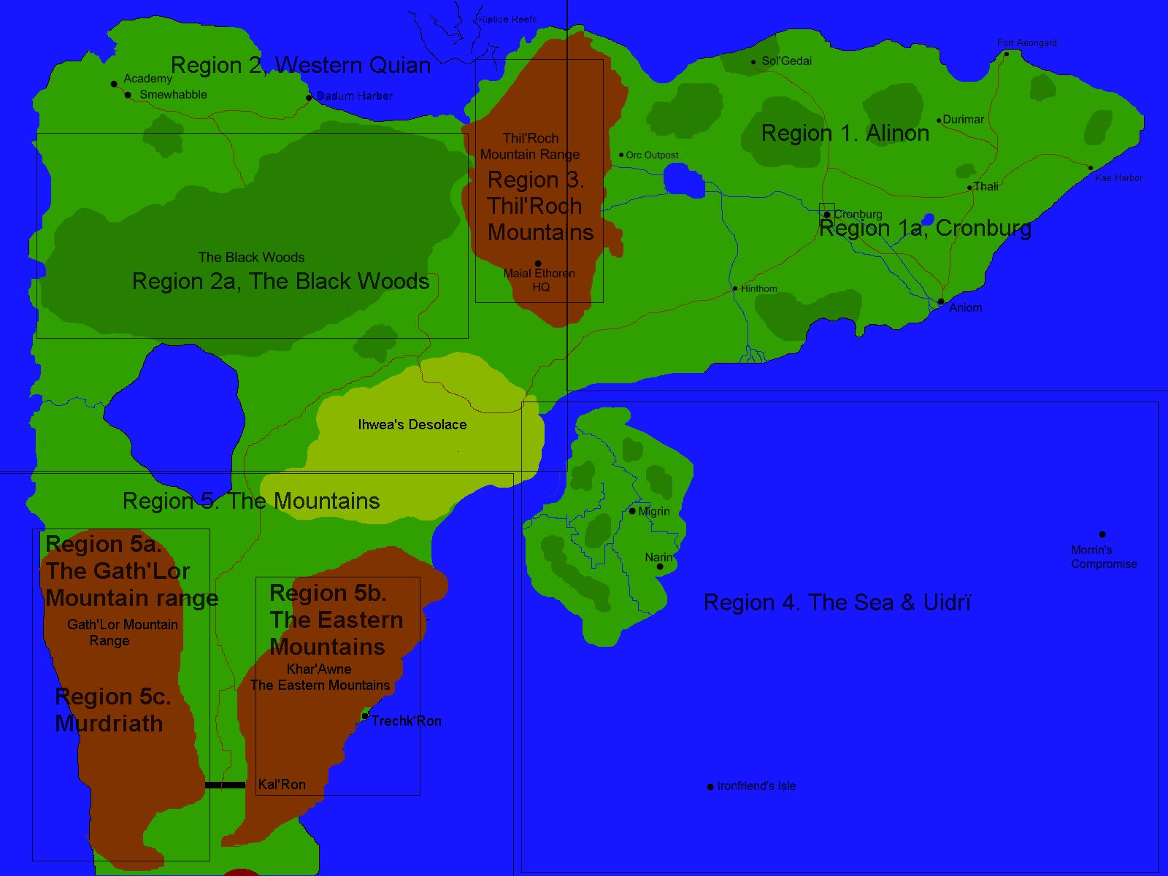
As some people like to call it, the setting. Quian’Dor is a world that has history behind every single one of it’s zones, be it the cold mountain peaks of Gath’Ron, or the draught wastelands of Ihwea’s Desolace. The world that we have attempted to create is constantly evolving due to story developments and afcourse our own input on how to make it better. To give a general overview, I would like to show the reader a map that I drew recently, so here it goes.

Region 1. Alinon.
Alinon is the only human realm on the Quian continent. We, being humans, understand the need of reproduction and we have actually known no actual opposition in our history, at least not from other races. The Quian’Dor humans have fought wars against every other race in the world, and still they remain numbered. The Kingdom of Alinon is ruled by a King, as the name suggests, that has been a member of the Cronburgian Royalty, they who ride under the banner of the Badger. After a long period of war against an enemy nation, they became the victors and now the Badger King rules the entire domain.
Region 1a. Cronburg
Ah, Cronburg, the Jewel of the North. This massive city is the capital of Alinon, and is surrounded by thick walls and strong rivers, making it almost impossible to occupy. Almost ten percent of the humans live here, approximatively 120 000 in number, as well as vast amounts of Elves and Dwarves. See attachment 1.

Region 2. Western Quian.
Western Quian, or as we internally call it, “the rest”, is the area to the west of the human realm, and is mostly covered by an area that we call The Black Woods. This forest was once erected in a desperate act of a Halfling Mage, and is now exceedingly dangerous and considered impassible. North of this forest lies the Halfling Realm of Smewhabble, the Halflings are a fascinating race of intelligent midgets, to say it roughly. They have built the Academy of Magic and are considered the most potent users of Magic all over the continent. This Western part of the world will be released later, but more on that later.
Region 2a. The Black Woods.
The Black Woods is featured in its entirity as an area because we really want to catch the feel for it. Its a damp place, full of dangerous animals and plants and for a long time no one has ever come out alive.

Region 3. The Thil’roch Mountains
The mountains of Thil’Roch are a mysterious place, once it was the abode of all the races, but it was soon abandoned, it is now the domain of trolls and bandits, and it is rarely visited these days. The mountains are a maze of caves and tunnels and often mining expiditions attempt to set up camp, but get chased off by the inhabitants of the tunnels...
Region 4. The Sea & Uldrï
The ocean of Quian’Dor is a treacherous one, for it hides many reefs and sandbanks below its surface, invisible for the untrained eye. A lot of small islands are scattered around the ocean, waiting for someone to inhabit the islands.
Uldrï is the home of the grayish, small Uldriai. They are gray of skin, short of size and extremely arrogant. Uldrian cities reflect their maginificent arrogance, for it is an island with the grandeur and beauty that surpasses even Galin-Dalar and Gath’Ron.

Region 5. The Mountains
Two long mountain ranges form the view in the fifth region. Between them, for they are not linked as you can see, lies the massive Dwarven fortress Kal’Ron that is aptly nicknamed “The Wall”. It alone defended the Northern lands against an Orcish onslaught, and it is considered unbreachable, for never has an enemy conquered the entirity of Kal’Ron.
Region 5a. The Gath’Lor Mountain range
The Gath’Lor Mountain Range are the mountain’s where the Dwarves have settled in when they left the First Realm. These mountains, aptly named after the Dwarven race, holds the capital of Gath’Lor, the Dwarven Empire, as well as most of the settlements of the Dwarves. It is home to many caverns and tunnels and the Dwarves keep digging deeper and deeper into the ground, be it with care.
Region 5b. The Eastern Mountains
The Eastern Mountains are home to one single Dwarven city, Trechk’Ron. This city is settled on the foothills of the mountains and is home to many a trader, be it Dwarven or other of race. The rest of the mountains are scarcely populated, with here and there a small settlement, and on the peaks of these mountains there are altars to all the gods, carved out by an unknown civilization.
Region 5c. Murdriath
Deep below the Gath’Lor empire lies Murdriath, home to a forgotten race of people called the Murdriai. These strange creatures haven’t had contact with the outside world for ages and for now their empire lies sealed off deep below the halls of Gath’Ron.
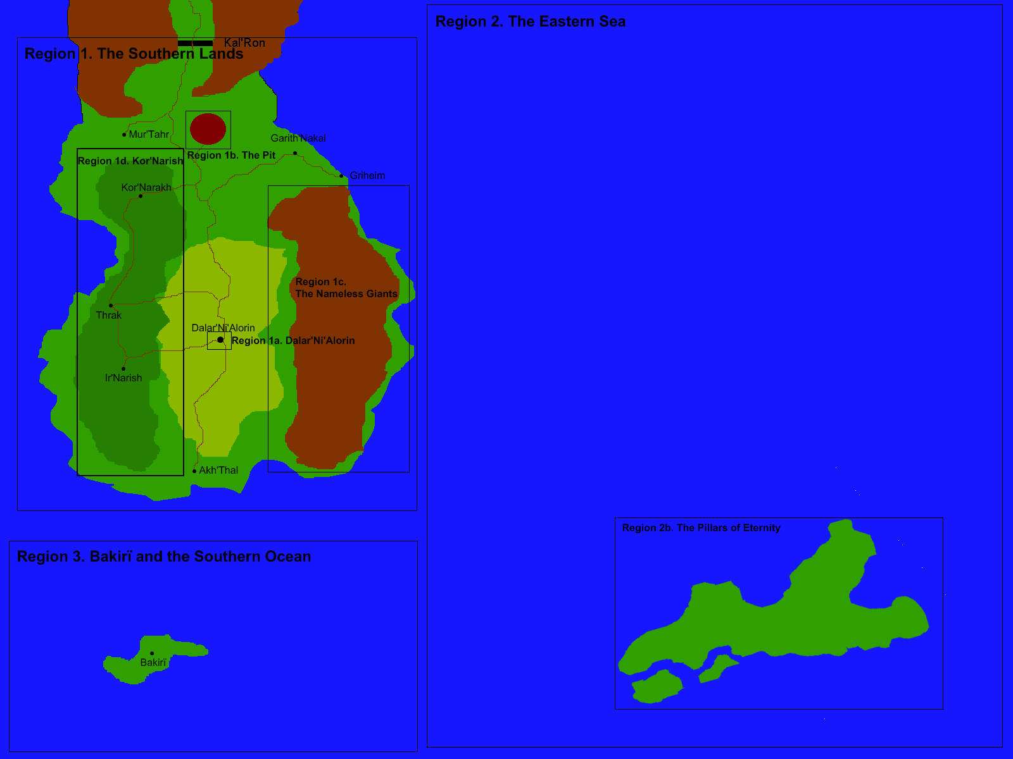
Chapter 1b. Southern Quian’Dor

Region 1. The Southern Lands. These southern parts of the burstling continent is filled with something often marked as evil by the northern races. The Drow who had come here that long time ago have oppressed all of the native races that inhabited its rich landscapes. The lush fields that are now called the Gray Plains have all but dried up by the terrible fumes and magic powers that pour out of the black pinaccle that is Dalar’Ni’Alorin.
Region 1a. Dalar’Ni’Alorin. The capital of Dalar’ni’Alorin is based on the southern plains and is the most terrifying building on the continent. Behind a large black wall is a tower that reaches into the clouds. It was designed by Mir’Luin Aeril, who also drew the palace on Galin-Dalar. At the base of the tower are the smithies, the alchemist and all the professions based on heating things. In the lower parts of the towers are the habitats of hundreds of Drow, the apartments go to about 2 stages below ground. Below the apartments are the dungeons. Here the mages experiment with spells and weapons. And here they keep their prisoners. Above the housings are all the “clean” professions. With Clean professions we mean everything that doesn’t produce smoke or nasty scents. Above these stages are the homes of the Drow Lords, here the royals reside and here they torture their prisoners.
Above this all is the Southern Academy of the Higher Arts. As opposed to the Northern Academy of Magic the Drow established a second school. This school is the only school that the Drow, allow to have. Orcs who have the gift for magic get dragged to the tower to control their powers and all of the Ir’Galin that have the gift go there themselves.
Region 1b, The Pit. Once upon a time two massive armies clashed on this location. The raw magical energy wielded in this place a long time ago carved a massive crater in the ground. The potent energies within here are so unstable that they twist and warp everything that dares to descend into this gaping hole.
Region 1c, The Nameless Giants. The high peaks of the Nameles Giants are a lifeless place, inhabited by just dragons and vermin. The dragons are, contrary to legends and myths, unintelligent and primal, savage creatures. The dragons feed on their own kin and will leave everyone alone untill their territory is threatened. Dwarf chronicles have told about caves in these mountains inhabited by their kin, but never has anyone found an entrance.
Region 1d, Kor’Narish. This thick forest is home to one of the three major Orc tribes. The Kor’Narish have settled here in wooden shacks and huts and haven’t moved ever since. The game in the forest is dangerous but big and nutritious, and famine rarely strikes the orcs of the Kor’Narish.
Region 2. The Eastern Sea. The ocean of Quian’Dor is a treacherous one, for it hides many reefs and sandbanks below its surface, invisible for the untrained eye. A lot of small islands are scattered around the ocean, waiting for someone to inhabit the islands.
Region 2b. The Pillars of Creation. This island has never been fully understood. All that is there is a big amount of stone pillars, with diameters spanning from a few inches to a mile. Inhabited by the servants of the gods, known as the Aven.
Region 3. Bakiri and the Southern Ocean. No one knows what lies beyond the Southern Ocean, except for a few enterprising elf sailors who stumbled across Bakiri on their journey. This island is inhabited by ferocious creatures called Baki. Little is known how the Baki managed to travel from this island to the Black Woods, but they seem to be the same species, according to legends. Not much else is known about this island.
Chapter 1c. Regions Outside of Quian
Galin-Dalar. The island of Galin-Dalar has been the home of the elves since the counting of years began. The rich soil of the island gave birth to an incredible amount of trees, and this island has been all but covered by trees shortly after creation. This island will be a minor release somewhere between chapter 1 and two of the development story..
Tuen’Dora, the Lost World. This continent will be featured in a later story, after the downfall and destruction of Dalar’Ni’Alorin, the surviving members of the Maial Ethoren have fled to this mysterious continent, fighting a desperate struggle to build up civilization and survive the war against the savage inhabitants.
Ihwea’s Empire. This continent is home to the fled worshippers of the god Ihwea, he who is all. This continent is ruled by an emperor and his elected Ministers. This continent will play a major role as the enemy in the second development chapter, where Robert and Mir’Rith lead the Crimson Tide to conquer Quian, laying the foundation for the empire of Truth, Maialin.
Geon Dar.(Godly Keep) This is the alternate dimension from where the gods watch their creation unfold. Here Naem manages the souls to their bodies, and from here Morrin manages time itself. The player will only visit this place as he selects the character he wants to play with.
Chapter 1d. Playable Races
The Murdriai
Race in Aveïn: Mur’Lin
(Biggest) Nation: Murdriath (See Nation Chart: Murdriath)
Name Singular: Murdrian
Name Plural: Murdriai
History: --Chapter 1, Rise of Murdriath--
The Murdriai were first made in unison by Muinen, Awne and Lañes, to create a race of guardians for the Core of Magic. The Murdriai, however, seemed to fear the Core, and they created a barrier of rock around it, as soon as they were done, the Core of Magic pulsed, and the rock layer turned into Crystalis. The Murdriai saw it as a sign from the gods who, in their belief, made the Crystalis, and they attempted to excavate the Core. A large shaft was dug around the Core, that was at least 10 paces wide by now, and the shaft was dug over a course of thirty years, after which the leaders of the Murdrian race, small in numbers so short after their creation, decided that it was endless. The leaders declared that they would settle themselves around the Core to hear the will of the Gods, and the whole race began to build houses in the wall shaft, connected by stairway hubs. Soon the city began to grow out of the shaft and it split up in districts, creating a caste system with strict rules and habits.
--Chapter 2, Downfall--
During this time, the welfare of Murdriath grew and her population thrived. The leadership of Murdriath that time consisted of a league of Arch Magi, all having their little schemes for more power and the death of their opponents. In the end of this internal power struggle, one man came out and declared himself King of Murdriath. His name is not mentioned anywhere but he was the first of what seemed to be a long dynasty of Kings, as he already had grandchildren at the age of 65. However, a mere year after the coronation, a terrible plague swept the mushroom fields, killing countless Murdriai. The King ordered the central city to be locked in await for the plague to pass, but then disaster struck. The entrances on the side of the central city caved in, and the central city inhabitants had no way of breaching the cave walls. No word reached the outer cities of the peril that struck the Core District, since they were still fighting back the plague that swept the caves. The people in the Core District quickly turned against each other in a fight for the last food, and eventually it died out, and the district is still locked out due to the belief of the lower caste in the King’s return.
--Current Status--
Murdriath is currently still split up into two halves, the one half is the abandoned Core District that starved during the Plague, and the other half is the rest of Murdriath, the farmers with their families, the craftsmen and the soldiers. There is barely any organization and the current leader of the Murdriath Empire is basically the Executioner, He who brings Law, since he keeps the peace and no one dares to lay a hand on him. The Murdriai still live on unnoticed underground, not even by the dwarves, who have not dared to dig so deep.
--Physical features--
Size: 2.00 – 2.40 meters for a male, 1.90 – 2.30 for a female, they are strong, bulky and muscular.
Skin tones: From Moss green to rock gray.
Facial Features: Strong chins, medium noses and big round ears.
The Elves
Race in Aveïn: Galin
(Biggest) Nation: Galin-Dalar (See Nation Chart)
Name Singular: Elf
Name Plural: Elves
History:
--Chapter 1, Creation and separation—
From the start of creation, the elves knew they were different then the other races. More tranquil and calm, they seemed to resemble, unlike the other races, the Aven more than the Allin. They marked the start of their counting of years when they settled on the island of Galin-Dalar, the massive forests gave the elves the rest they needed, and they were peaceful for 214 years. In this year a rebellion within the ranks of the nobles seceded from the nation and decided to form a nation based on their own beliefs somewhere else. They traveled to the Southern Lands and settled there, naming themselves Drow, or Ir’Galin.
--Chapter 2, War –
The Elves decided to wage a massive war on the Drow, and they started an alliance with the Northern nations. Eager to shed the blood of their former kinsmen, the Elves declared them their mortal enemies, never to reconcile with them. During this horrible war, an elf named Finglos formed an order to fight the Ir’Galin and their influence, and with massive amounts of magic power he created an island called Muinen’s Gift. The island held a Crystalis big enough to flatten mountains, but eventually the island sank into the ocean’s depths, doomed to be forgotten by all but a few.
--Current Status--
Galin-Dalar is currently under attack by a large warhost of Ir’Galin, who have taken foothold on the eastern end of the island. A constant struggle for dominance is being fought, and the Drow refuse to give in, slowly but steadily expanding their territory by burning down trees and foliage.
The elven population has spread across the northern lands to settle with humans and dwarves alike, their most prominent settlement outside of Galin-Dalar is the glade of Sol’Gedai, which is based around a temple to Muinen in northern Alinon.
--Physical features--
Size: 5’9 to 6’9 feet, thin, frail, and agile.
Skin tones: Pale to tanned skin, like humans but lighter.
Facial Features: Sharp noses, smooth eyebrows, pointy ears and intense eyes.
The Drow
Race in Aveïn: Ir’Galin
(Biggest) Nation: Dalar’Ni’Alorin (See Nation Chart)
Name Singular: Drow
Name Plural: Drow
History:
--Chapter 1, Shattered—
In the year 214 an internal struggle for power caused half of the Elven population on Galin-Dalar to sail away in anger. Their powerful magic got them over the ocean to the wasteland that is now called the Southernland. There they found a race of massive Ogres. The Ogres got mutated by the vile magic of the Drow and are now called Orcs. The Drow led the orcs on a path of savagery and bloodlust and made them wage several wars against the Northern races.
--Chapter 2, Annihilation –
In the year 351 the Drow put an orc named Dian Gragar up as commander of the tribes. The cruel but cunning Gragar lead the orcs to an earthshaking victory at Kal’Ron, only to be driven back by a massive Dwarven army bolstered by the might of the elves, humans, and Halfling magi from the North. After they got driven back into the Southern Lands, the Drow joined in on the battle with full force, and both armies clashed somewhere south of Kal’Ron. The magical forces wielded lit a beacon that could be seen from miles away, leaving nothing but a pit of twisting magical energies in its wake. The entire army was wiped out, and neither the Northern as the Southern Academy could ever regain the power from before the Pit.
--Current Status--
The Drow have become increasingly hostile lately, and they even managed to land on the shores of Galin-Dalar in an attempt to wipe out their “pathetic” kindred. The Drow are still controlled by someone only referred to as the Highmaster, and he holds the strings of power tightly in his grasp. The Drow population is sparsely spread outside of Dalar’Ni’Alorin, but almost every city in the world has one or two Drow that serve as spies for the Highmaster.
--Physical features--
Size: 5’9 to 6’9 feet, thin and frail. And very agile.
Skin tones: Gray skin, in several tones.
Facial Features: Sharp noses, smooth eyebrows, pointy ears and intense eyes, shades from blue to red and sometimes even black.
The Dwarves
Race in Aveïn: Thath’Lin
(Biggest) Nation: Gath’Lor (See Nation Chart)
Name Singular: Dwarf
Name Plural: Dwarves
History:
--Chapter 1, Digging—
When the Dwarves got driven out of the Human lands, they settled in the natural caves that had formed under the peaks of the Gath’Lor mountain range. Within years they had built up their massive city of Gath’Ron with its mighty halls and extreme fortifications. Between the other cities, the dwarves would dig an intricate network of tunnels and hallways, called the Underworld. The strong belief that they were the defenders of the frail human races, who were constantly fighting amongst themselves, drove them to build a fortress called Kal’Ron, or the Wall. Over the years the Wall would withstand many challenges, though none as great as the army of Dian Gragar.
--Chapter 2, The Pit –
The orc warlord Dian Gragar managed to breach the wall, and disperse the Dwarf forces back to their strongholds inside the mountains that they call Vaults. A massive army from the north, however, managed to liberate the wall and drive back the attackers. The dwarves got renewed faith in the war, and joined the northern army in an assault at Dalar’Ni’Alorin. They found themselves standing eye to eye with another army from the south, and after the battle was over, there was nothing but a wasteland called the Pit.
--Current Status--
The Dwarves have thrived still, and their society focuses on the welfare of the nation. Kids are being raised to make a valuable addition to society, and there is always work to do in the tunnels of Gath’Ron.
--Physical features--
Size: Around five feet. 4’10 to 5’2, sturdy and resilient.
Skin tones: Like Humans, but more tanned.
Facial Features: Square noses, bushy eyebrows, normal ears, urrowed brows and deep-socketed eyes, hair color spanning from brown to red, eye colors like humans and gold.
The Humans
Race in Aveïn: Allin
(Biggest) Nation: Ihwea’s Empire, Alinon (See Nation Chart)
Name Singular: Human
Name Plural: Humans
History:
--Chapter 1, Origins—
The Human race was designed by the gods to be a balance to the long living elves. To ensure that humans would be a race that enjoys, they gave them a lifespan for up to a hundred years, giving the Allin a sense of haste and sudden urges. Unknowingly they created a race that would never be truly stable. The humans drove the other races out of their lands, and then waged war upon each other for centuries. About religion, science, or just greed, the humans were never shy an excuse to wage war. Only once they were united in a cause: The Great Orc Uprising, often called the War for the Wall, and not until the year 397 they formed a society that was truly their own.
--Chapter 2, Prosperity –
When lord Rion Biunlor conquered the entirety of eastern Quian, people thought he’d be off his throne in no time, but the war with Ihwea’s followers left the country in need for a strong leader, and that he was. The lords of the almost decimated population of the regions that are now called Alinon bound themselves to the Badger’s Throne with oaths stronger then stone, and the Dukes and Counts still rule the land in king’s name in this day. The humans are still ferocious, but now focus on intrigue and political games rather than mindless manslaughter.
--Current Status--
Alinon and Cronburg have grown out to be pearls of beauty and splendor, and are often the envy of orcs, and the target of many raids. A group of humans sympathizing with the Drow and their motives have settled in the southern lands, and a lot more have spread over the Northern Lands to fulfill their dreams.
--Physical features--
Size: From five feet to 6’2
Skin tones: Pink, tanned to pale. Southern humans have a brown skin.
Facial Features: Red, Blonde, brown, black hair, sometimes white, humans have the tendency to dye their hair. Round ears, blue/brown/green eyes in various tints.
The Orcs
Race in Aveïn: Og’Rath
(Biggest) Nation: Kor’Narish, Nak’Narish, Al’Narish (See Nation Chart)
Name Singular: Orc
Name Plural: Orcs
History:
--Chapter 1, Flesh-Warp—
When the Drow encountered the now extinct Ogres, they immediately saw the possibilities behind these savage brutes. Using their vile magic the Drow magi warped the ogre’s flesh into something that looks completely different than anything seen before. These newborn Orcs were more savage, but also got a larger brainmass, making them a deadly and cunning opponent. Immediately they swore loyalty to the Drow, keeping in the back of their minds that they would be able to overthrow the Drow one day.
--Chapter 2, Power –
One ambitious orc named Dian Gragar rose to power in the year 351 and he managed to unite the Tribes for a war effort against the Northern Lands. The war that followed had more than half of the entire orc population fighting the hated Dwarves, and none of them would ever return from the war. The Orc population was without leadership for a hundred years, seeing as the Drow had to take care of their internal affairs, and they fought amongst themselves ever since, with the Drow unable to calm them down.
--Current Status--
The Orcs are still fighting amongst themselves and the Drow have only managed to stop a few clans from waging war. The tribes have grown, however, to incredible proportions and are now a threat to anyone in case they are united.
--Physical features--
Size: Around 6’’6, broad shouldered and with a natural strength.
Skin tones: Green, from moss green to beige, depending on the habitat.
Facial Features: Blood-red, Black, white (shamans) hair. Eyes can be blue (in rare cases), but they are often red or purple. They have long, pointed ears, but the point is at the bottom and the top is rounded. Solid, square noses.
The Halflings
Race in Aveïn: Im’Lin
(Biggest) Nation: Smewhabble (See Nation Chart)
Name Singular: Halfling
Name Plural: Halflings
History:
--Chapter 1, Creation—
At the day of Creation the Halflings were uncertain that they were very much alike the other races, and when the ogres revolted they fled to a place that would be their home, Smewhabble. Here they found the base for what would be called the Northern Academy of Magic. The Halflings thrived and took a lot of students in from the other races, but the Academy wouldn’t reach its peak of power until a centuries years later.
--Chapter 2, Arcanum –
When the Drow seceded from the Galin in the year 214, the Halflings got afraid, and expelled all elves from the school. The elves, most of them sympathizers of Mir’Luin and the rebellion, got bitter and moved to the south, there they founded the Southern Academy of the Higher Arts. The ties with the Galin got renewed and the power and influence of the Northern Academy grew. When Finlgos started his massive project to defend the Northern Lands with the biggest Crystalis ever made, the Halfling magi were eager to join in to help. When the Crystalis was complete the popularity of the Northern Academy rose to an absolute high, and nothing matched the beauty and majesty of the school.
--Chapter 3, Solitude--
After the war for the Crystalis the Halflings were afraid of the Southern Lands more than ever before, and decided to reinforce their defenses by building magical traps inside a forest that was called the Barrier Woodland. No one could get through this forest anymore, besides the Halflings, so they were safe. But then disaster struck, the massive powers wielded attracted a ferocious kind of creature called the Baki to the forest, where they infested the underground tunnels and caves that were scattered underground of Smewhabble. The storms that haunted the seas around Smewhabble grew worse, and the Halflings effectively got isolated from the rest of the world.
--Current Status--
The Halflings have forgotten their old-allies, and they have turned to their studies in the hope to calm the storms, and be free to sail and trade with the outside world once more. Smewhabble is thriving, but they are forgotten by the rest of the world.
--Physical features--
Size: Up to 4’8, fast minded and bodied.
Skin tones: Pale pink.
Facial Features: Halflings have blonde or black hair, which turns gray around their 50th year. Eyes can vary between blue, purple, and white, as well as brown and green. They have small noses and ears, and often resemble bearded little children.
Chapter 1e. Other races.
Ogres. These savage brutes were the ancestors of the orcs, but due to their slow reproduction rate and small brains, the entire race is extinct from Quian.
Kobolds. A wicked offshoot of Halflings, created by a Drow wizard who attempted to duplicated the Halfling’s complex minds.. These Kobolds have never been able to be controlled by anyone, and their instincts rule their minds. They live in small numbers in caves deep under the earth, and only the Drow know of their existance.
Avë. The winged arbiters, these flying creatures have extreme magic potential and live only to keep track of history and to serve the gods. They are in a constant struggle with the Ir’ Avë, the fallen Angels to make sure that no one disrupts the ways of destiny for the mortal races.
Ir’ Avë . Arch enemies of the Avë. These mad angels have renounced their old masters and now work according to the teachings of a new god. They want to steer the mortal races on a path of destruction and annihilation. They are nearly always the cause of strife and war.
Chapter 1f. Factions.
The Assassins Guild was originally a group of Sorrowers that were trained for killing the Enemies of the leaders at that moment. The leadership of Dalar’Ni’Alorin consisted of seven Drow Sorcerers and the Assassins Guild (Called the Ninth Regiment at that point) had loads of work. But eventually the Sorcerers turned against each other and the Ninth Regiment chose to stay out of this, before the Sorcerers would come for their help, which, they thought, would happen soon. They thought correctly, for the Sorcerers quickly asked for their help. But they declined and the leaders got so Furious they all, without knowing that the other Sorcerers already did the same, disbanded the Regiment.
The leader of the Regiment, Zichnen Xandich, housed everyone of the Regiment in his house and started accepting payments for assassinations. The Orc warlords were quick to buy the services of the guild and Lord Xandich called himself High Imnat of the Credux, which is a name that the Drow often give to events that are set in motion by their god Manigez. But the Credux was commonly called the Assassins Guild and only the rank of High Imnat remains up to today. Zichnen got so incredibly rich for his services that he made branches in every city where Drow lived and after a while they were able to enlist several Halflings in their ranks, and thus expanding to the Northlands.
The Assassins Guild now reaches all over the known world and enlists Assassins of every race.
The Glass Fist was founded by Finglos and his most ambitious friends. This organization tries to make sure that there is a magic user on every throne in the Northern Lands. When Finglos died the Glass fist grew weak, but in recent years has seen a revival when magic was about to die out. They have steered onto a new course of attempting to reignite the flame of magic across the world.
Maial Ethoren is Mir’Riths dream of a nation focusing around the ideology that everyone is equal as long as they try. Maial Ethoren will be the first faction in the game as they players fight (with) Mir’Rith as he tries to conquer the entirety of Quian. See more in chapter 1h.
Chapter 1g. Gods
For the Gods, creation is only a game, be it a very intense one. They decided to play when, in their previous game, all followers lost belief in god and decided to live their own lives. Quian’Dor was made with a new set of godly rules, but those exact rules are only known to them. In Quian’Dor, the gods will play a major role in gameplay, for this see chapter 2m.
Awne, whose passion lit the sun and created the moon. She is the entity of light and hope. She is tranquil, calm, and forgiving in nature.
Muinen. The strong and willful Muinen has loved the elves since the first dawn. She is the creator of Mountains and Valleys, and primary entity of earth. Muinen is patient, but firm in her anger.
Lañes. He is the Entity of Fire. His fierce thoughts made volcanoes and lightning. He is the Master Craftsman god, and favors the Dwarves. He is short-tempered and passionate.
Morrin. The Time himself. He had the power to create days and nights. He isn’t worshipped since you cannot earn his favors, time is everflowing. Morrin will possibly feature in a story development regarding balance, and the Ir’Avë/Avë war. He is calm and nonchalant.
Faragon. He is the protector of hope, rival of Manigez. He is the guardian with the hammer and shield, he favors the Northern races. He thought of heroism and nobility. He is loyal and kind, though strong willed, he and Manigez are the Warrior Gods.
Manigez. Arch Rival of Faragon armed with a huge black spear, he is the patron God of the Drow. Manigez thought of betrayal and deceit. He is mean and arrogant.
Faghm. Faghm is the feral god. He thought of hunger and desire and is most worshipped by the Orcs. Faghm barely has any human emotions, and only wants to fulfill his desires.
Astirun. Astirun is the god of love, friendship, and loyalty. Astirun loves everyone, and cries for everyone who dies.
Remirun. The brother of Astirun and the god of luck, coincidence and entertainment, this god is called the Prankster by some. He is worshipped by thieves and gamblers and most people belief him to be the blame for everything that goes wrong. And, quite often, he is to be blamed. Remirun has a quick wit and a sharp mind, and a sarcastic sense of humor.
Naem, The Soulkeeper.
Naem is often seen as the twin brother of Morrin, as they are both neutral and as they both are never worshipped. He is incredibly powerful but uses his power only for creating the souls in the Palace of the Gods. In a hall in the middle of this massive castle Naem sits on a simple chair,
crafting souls every moment of His time. He is modest, and friendly, though a bit vague, in personality.
Chapter 1h. Magic
Magic on Quian’Dor is as revered as the gods, and about as powerful. The source of all magic is an object called the Core of Magic. This massive spire that is seemingly part of the World’s core, fuels all magic users, unbeknownst to anyone but the gods. The Murdriai protect the Core of Magic from deep within the Mountains, and only a handful of people on the surface world know of its existance.
Five flows of magic come from the core, and each flow has its own unique characteristics.
Water. Created from Awne’s tears, the water flow defends and heals the user and his allies.
Fire. From Lañes’ fiery hair, the fire flow burns and cleanses everything in its wake.
Earth. From Muinen’s hands, the flows of earth amplify life.
Wind. From Morrins breath, the flows of wind push and pull all things that are susceptible to change.
Mind. From Naems eyes, the flows of the mind intrude and protect, inducing rationality or fear.
For more information on Magic, read chapter 2d
Chapter 1i. Releases
The story of Quian’Dor will unfold in phases, these so called Phases can last from a few days to a few months at the time, depending on player activity and skill. Every phase goes on into the next one as the story progresses. Phases can be added or removed as the staff see fit, to ensure maximum enjoyment and gameplay.
Phase 1. Eruption.(North Favored)
1. Mir’Rith and Robert choose their paths to make the world a better place. (Players will do small quests involving piracy and island claiming, as well as some skirmishes with the opposing faction)
2. A War for the Wall will erupt. (Players fight the war, making the difference from an otherwise stalemate.)
3. Smewhabble will be unlocked. (The players will have to travel through the Black Woods and fight hordes of baki to make sure that the way is clear. Possibility for a Baki dungeon)
4. The second War for the Wall is won. (Depending on which side has victored, that side will get additional equipment that is able to be bought and more shipwright options will be available.)
5. Half of Galin-Dalar is torched, Robert is furious and finds a cure for the burnt forest.(The burning is inevitable, but the Southern players can choose to fight and burn certain parts of the forest, up to half of it.)
6. He ends up in Murdriath, where they elect him as their leader. (This step will unlock Murdriath for players, and both sides fight to get Murdriath on their side.)
7. Phase ends with Mir’Rith starting the Ethoren Maial in the Thil’Roch mountain, where an abandoned village from before the war gets chosen as their headquarters.(Final phase involves a large scale battle between the players who chose to side with Ethoren Maial and those who stayed loyal to their original faction. The nations unite against Ethoren Maial here if there is too much EM players)

Phase 2. Tempest. (South Favored)
1. Mir’Rith conquers Alinion and almost all of the surface world in the north. Gath’Ron and Smewhabble resist. Sol’Gedai succumbs to his will. (Continuation of Phase 1 step 7. Cronburg sides with Mir’Rith through propaganda.)
2. The southern Highmaster unites the Southern Lands and marches to the north, he lays siege on Cronburg. (Players side up with the Highmaster or press on Mir’Riths forces from bases like Smewhabble and Gath’Ron. Cronburg will not get destroyed, only captured.)
3. Cronburg battle gets decided, and the victoring army marches on to the Thil’Roch mountains or Dalar’Ni’Alorin. (Players will fight obstacles like fortresses and keeps, and ambushes to reach their destination. The other side causes these obstacles.)
4. Battle for Ethoren Maial or Dalar’Ni’Alorin. (Battle against Mir’Rith or the Highmaster, both escape before they die. City will be conquered, not pillaged.)
5. Crimson Tide lands on the Southern Alinon shore. (Players fight to repel the initial wave of invaders. If succesful, big rewards and calm for two in real life weeks.)
Phase 3. Blood Moon. (Equal)
Coming soon...
Chapter 2. Gameplay

Chapter 2a. Equipment
Equipment will be divided over twelve slots, each slot representing a different part of the body, and each slot having specific items associated to it. The item slots and their effects are as followed.
Gloves | Can enhance: Defense, physical attack speed, | Cloth, silk, Light Leather, Heavy Leather, Reinforced Leather, Chainmail, Heavy Chain, PlateMail, Gathrinium.
Pants | Can enhance: Defense, run speed, admiration | Cloth, silk, Light Leather, Heavy Leather, Reinforced Leather, Chainmail, Heavy Chain, PlateMail, Gathrinium.
Belt | Can enhance: Pouch capacity, defense | Cloth, silk, Light Leather, Heavy Leather, Reinforced Leather, Chainmail, Heavy Chain, PlateMail, Gathrinium.
Vest/Robes | Can enhance: Defense, admiration | Cloth, silk, Light Leather, Heavy Leather, Reinforced Leather, Chainmail, Heavy Chain, PlateMail, Gathrinium.
Hat | Can enhance: Defense, admiration | Cloth, silk, Light Leather, Heavy Leather, Reinforced Leather, Chainmail, Heavy Chain, PlateMail, Gathrinium.
Ring | Four slots, can enhance: magical protection, character stats, admiration, casting speed. | Copper, Silver, Gold, Steel, Darksteel, Gathrinium, Other.
Shoes | Can enhance: Run speed, defense, kick attacks. | Cloth, silk, Light Leather, Heavy Leather, Reinforced Leather, Chainmail, Heavy Chain, PlateMail, Gathrinium.
Shirt | Can enhance: admiration, defense. | Cloth, silk.
Right Hand | Holds weapon/shield/object. Can enhance anything, depending on the item. | Sword, Two Handed Sword, Axe, Two Handed Axe, Hammer, Two Handed Hammer, Mace, Two Handed Mace, Spear, Object, Bow, Crossbow, Throwing Daggers, Javelin, Dart Gun, Throwing Axes, Gun
Left Hand | Holds weapon/shield/object. Can enhance anything, depending on the item. | Sword, Two Handed Sword, Axe, Two Handed Axe, Hammer, Two Handed Hammer, Mace, Two Handed Mace, Spear, Object, Bow, Crossbow, Throwing Daggers, Javelin, Dart Gun, Throwing Axes, Gun
The stats that affect the player’s world skills are as followed:
Intelligence | Determines the amount of spells you can have memorized (hotkeyed) at the same time, and also increases the effect of magic. | Leveled by casting spells and reading books, and doing intelligence minigames/puzzles.
Agility | Is both mental and physical speed. Agility will improve side by side with your other stats, and affects your dodge chance, casting speed, movement speed. | Leveled as Intelligence and Strength increase, and can be leveled randomly by solving certain puzzles or games.
Strength | Determines your muscle mass. This determines how much you can lift and how hard you can hit. | Leveled by doing physical activies.
Vitality | Determines your health, endurance, and resistance to mental and physical diseases | Leveled per level up, and per strength increase.
Defense | Is the stat determined by your armor, can increase or decrease the more you get skilled with your armor type. | Depends on your armor value.
Luck | Determines how lucky you are in luck-based actions. | Cannot be leveled up, but can be affected by items.
Weapon Skill | Determines your skill with all weapons. | Can be leveled up by using weapons.
Racial Bonus | Intelligence | Agility | Strength | Vitality | Defense | Luck
Dwarf | 0 | -1 | 1 | 1 | 0 | 0
Elf | 1 | 1 | 0 | 0 | 0 | 0
Drow | 1 | 1 | 0 | 0 | 0 | 0
Orc | -1 | -1 | 1 | 1 | 0 | 0
Halfling | 2 | 1 | -1 | 0 | 0 | 0
Kobold | 1 | 2 | 0 | -1 | 0 | 0
Murdrian | 1 | 0 | 1 | 0 | 0 | 0
Human | 0 | 0 | 0 | 0 | 0 | 0

For more information, see the History documentation.
See Chapter 2k for the character creation and the Magic & Gods documentation for more information about Gaon’Dar.
Read Muinen’s Gift for the exact events.
Read “The Assassins Guild” document
For more: Read Muinen’s Gift

